
CATLETT

1616 16th Street
Central City, NE 68826
PH: 308-946-3112
Fax: 308-946-3122
Real Estate & Insurance

1402 10th Ave, Central City, NE
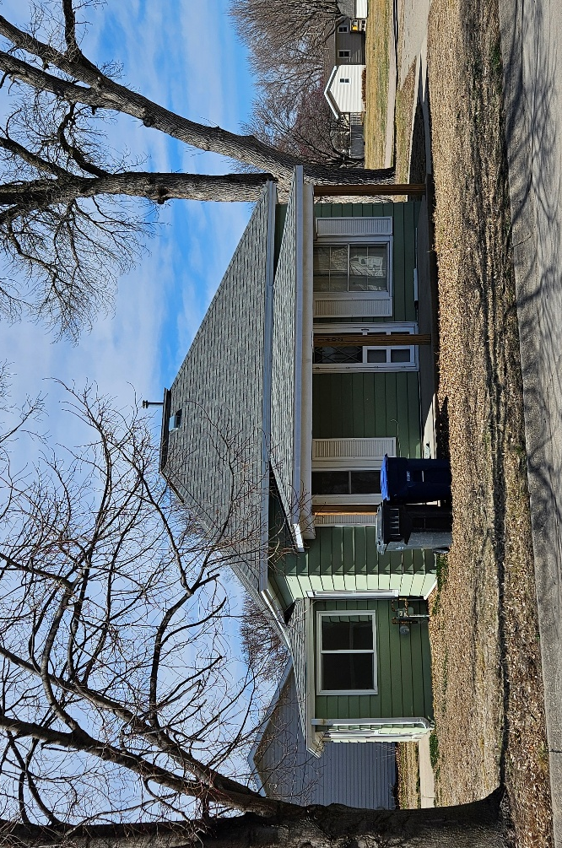

768 Sq. Ft.
2 Bedrooms – 1 Bath
1 Car Detached Garage plus additional shed
2025 Real Estate Taxes – $767.54
Asking Price - $160,000

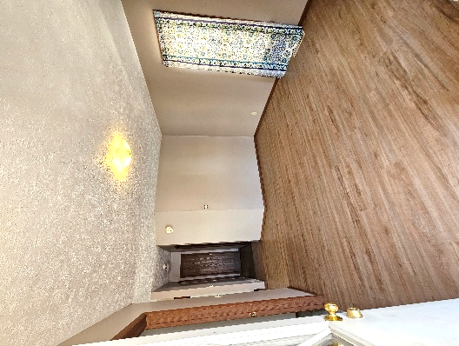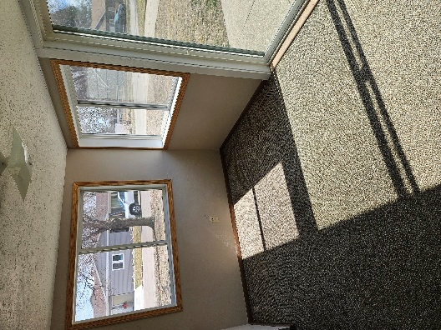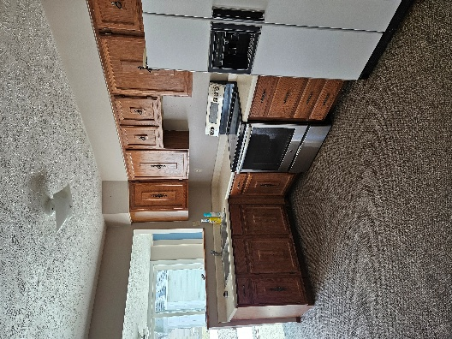
Living Room – 12’9” x 11’5” Dining Area – 12’7” x 7’5” Kitchen – 9’1” x 12’

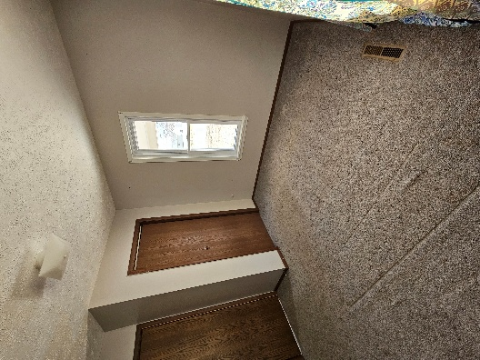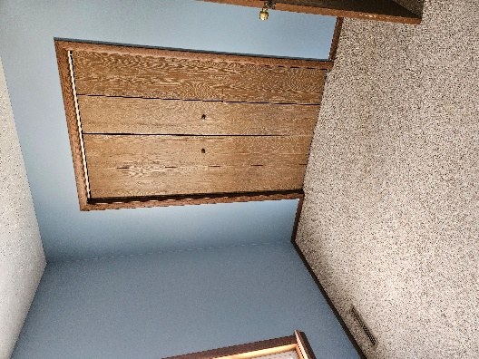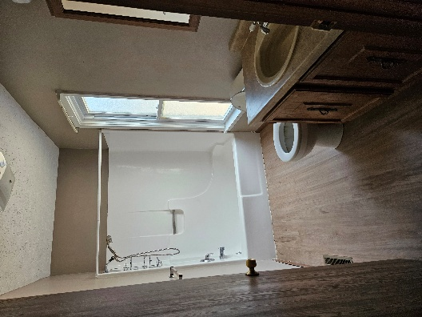
Bedroom – 10’4” x 11’6” Bedroom – 10’1” x 8’ Bath – 5’1” x 10’4”

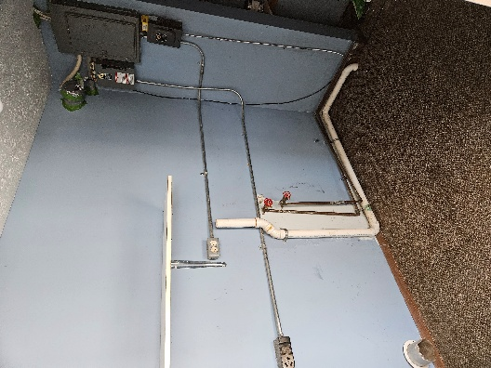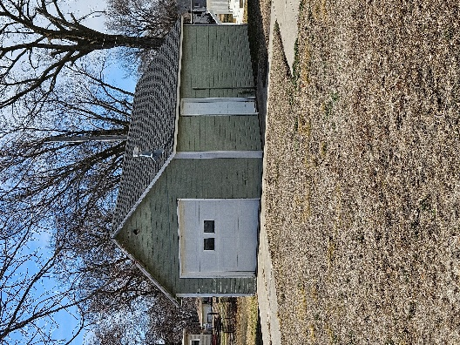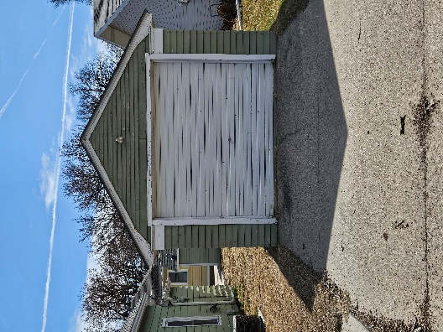
Laundry – 4’6” x 7’5” Single Detached Garage Additional Shed

