
Real Estate & Insurance

CATLETT

1616 16th Street
Central City, NE 68826
PH: 308-946-3112
Fax: 308-946-3122

2719 Terry Lane
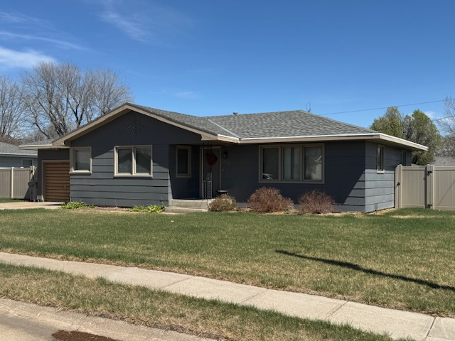
1,168 Sq. Ft.
2 Bedroom – 1 Bath
Family Room – Living room
Eat-in Kitchen
Privacy Fence around backyard
Yard Well for Underground Sprinklers
2025 Real Estate Taxes - 1,458.58

Asking Price - $190,000.00

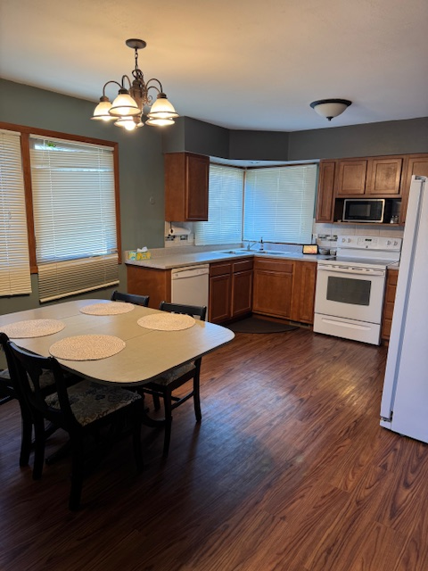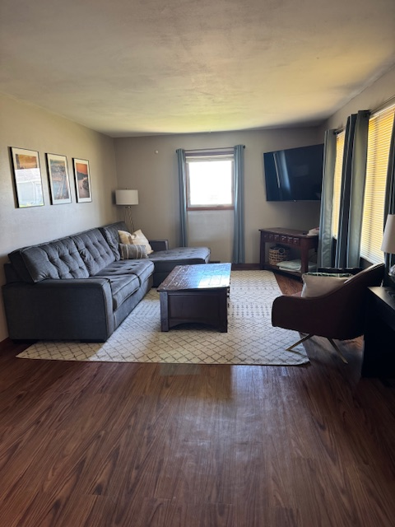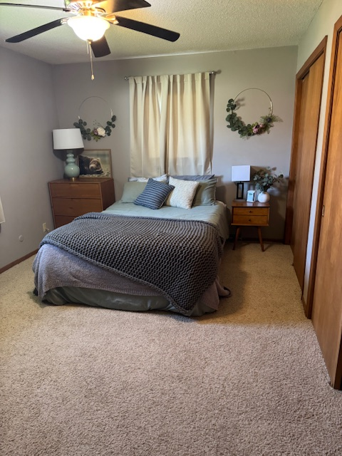
Kitchen12’ x 16’4” Living Room – 12’ x 22’8” Bedroom – 10’7 x 14’3
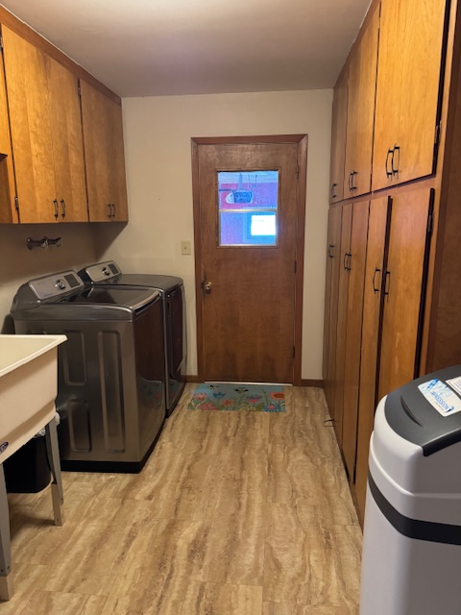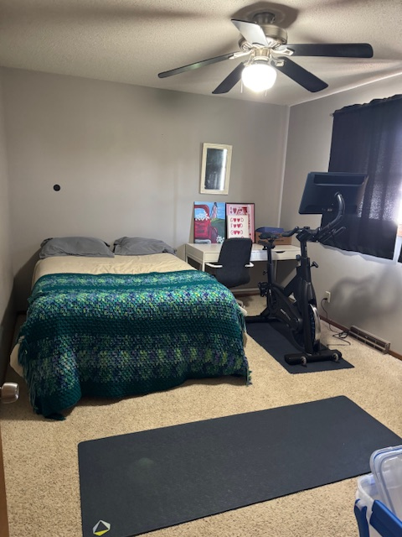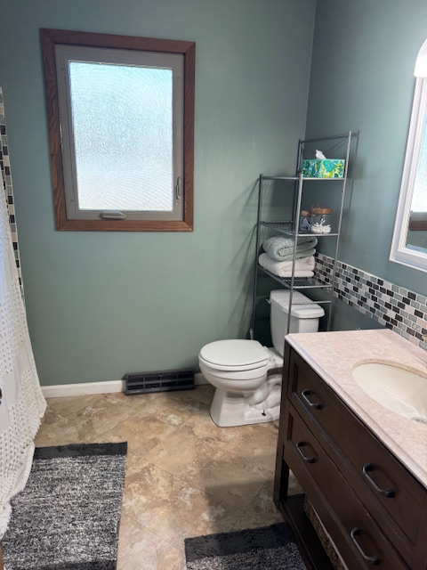
Utility room – 8’ x 16’4 Bedroom 10’7” x 13’2” Bath 7’3” x 8’
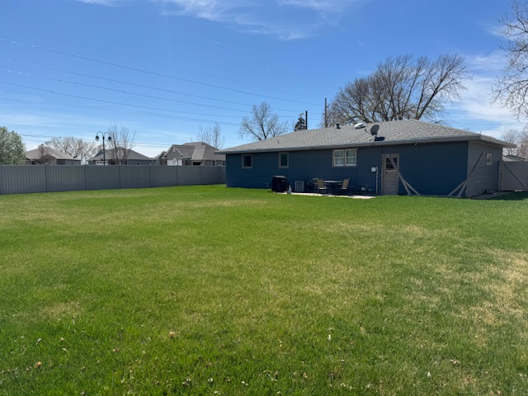
Backyard – Privacy fence

